

Version Number: 1.0

Version Date: 2019-05-06



Revision Log

|  |  |  |  |
| --- | --- | --- | --- |
| Version | Date | Author | Change Description |
| 0.1 | 2019-03-28 | Deanna Beauchamp | Initial draft |
| 1.0 | 2019-05-06 | Deanna Beauchamp | Final revisions for Phase 1 |
|  |  |  |  |

Contents

1. Introduction 3

2. Target Audience 3

3. Accessing the Roles 3

4. User Report 3

5. Roles 3

5.1. NGN – Expense Authority 3

5.2. NGN – Service Manager 4

# Introduction

The following roles have been created for use in NGN’s Dynamics 365 CRM instance.

Roles are applied to end users such as the delivery service managers and expense authorities. Roles are identified as either Primary or Additional. Additional roles are meant to be added on to a primary role to give the user a small amount of extra functionality. They are not meant to be provided without a primary role. Primary roles are meant to be provided on their own and should match the users job.

The Security roles are permissive, they provide the user with additive security. This means if one role states that a record cannot be deleted and another role states that they can delete a record when combined they will be able to delete. Roles should be monitored and administered by an administrator and reviewed on a periotic basis.

# Target Audience

The target audience for this document is business analysts, project managers and developers familiar with CRM.

# Accessing the Roles

All the security roles can be accessed through Settings > Security > Security Roles.  The tabs along the top show rights segregated in logical groupings. The legend at the bottom shows what level of access has been granted to all standard entities and custom entities as well.

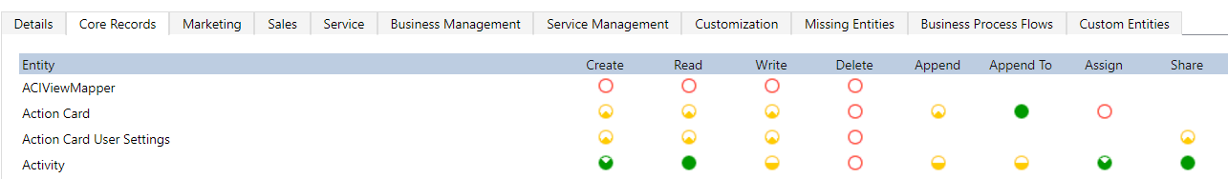



# User Report

A detailed user report that will allow the administrator to monitor user roles can be found under Service > Reports > User Summary.

# Roles

## NGN – Expense Authority

**Type**: Primary

**Description**: This role allows the user to approve orders. It also allows the user to view and modify financial records in the system. The user can view related information such as school districts, sites and site services. This role also allows the user to view relevant dashboards.

**Users**: This role will be used by expense authorities including Gabriel and James.

## NGN – Service Manager

**Type**: Primary

**Description**: This role allows the user to manage sites, site services and relating entities. It also allows the user to create cases and orders and to view dashboards pertaining to service delivery manager duties.

**Users**: This role will be used by Service Delivery Managers including Jason, Clinton and Trevor.